Name ____________________________________
STOP
and
THINK Sheet

Date ____________ Teacher _______________

Arrival ________ Return ________ Host Initials _______

Please check the expectation that was not being followed.
◻ We are Safe
◻ We are Respectful
◻ We are Responsible

What were you doing? ____________________________________________________________________________________________________________________________________
__________________________________________________________________________________________________________________________________________________________________________________________________________________________________________________________________________________________________________________________________________

What should you have been doing?
______________________________________________________________________________________________________________________________________________________________________________________________________________________________________________________________________________________________________________________________________________________________________________________________________________________________________________________________________________

Do you need help following the expectation? YES NO

Student Signature______________________________________________

STOP
and
THINK Sheet
Name ___________________________________

Date ________ Teacher ____________________

Arrival _______ Return _____ Host Initials ________

Draw a picture showing what you did. | Draw a picture showing what you should have done.

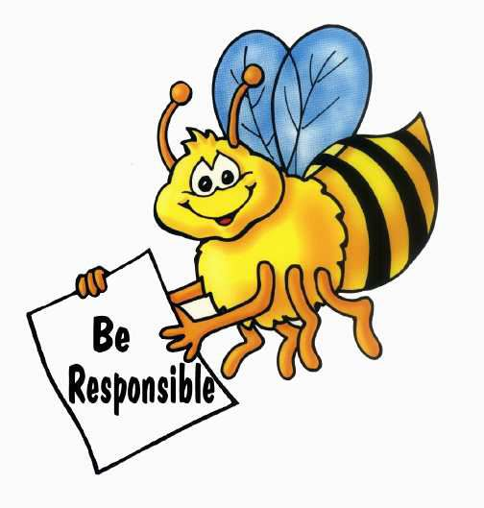
In the future you will…
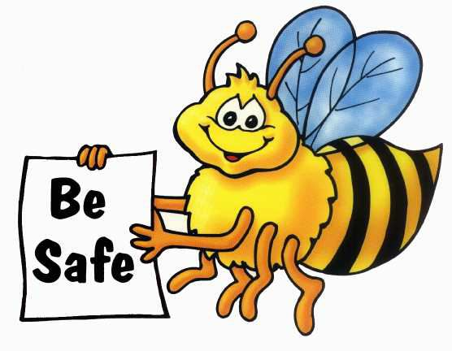


Reflection Sheet

Name:

Date:

Teacher:
What happened?

What were you thinking at the time of the incident?

What have you thought about since?

Who has been affected by what happened, and how?

What about this has been the hardest for you?

What do you think needs to be done to make things as right as possible?

